3GPP TSG-RAN WG4 Meeting #119 R4-2606023
Dalian, CHINA, May 18 - 22, 2026
Agenda item: 8.10.3
Source: CMCC
Title: Discussion on 6G sensing feasibility related aspects
Document for: Discussion

Introduction
In RAN#111 meeting, use case and sensing related requirements for 6G Radio are approved.
（9）Sensing – Studies to be based on use cases and associated requirements, as defined in [TR38.914]
- PHY functions and procedures for sensing technology (e.g., waveform. reference signals, measurement feedback, etc…) [RAN1, RAN4]
- Evaluate sensing performance and if necessary, extend channel modelling, for the selected use cases [RAN1]
- Aspects of integration with communication services [RAN1]
- higher layer procedures and protocol aspects [RAN2]
- RAN4 aspects of sensing including RF, coexistence, and testability in coordination with other WGs [RAN4]
Note: RAN1 identify detailed requirements, if triggered by TSG RAN

According to chairman’s guideline, the scope of sensing includes RAN4 related PHY functions and procedure, RF, coexistence and testability. According to moderator’s suggestion, this agenda will include both TRP side and UE side testing.
NOTE: companies are encouraged to share the possible RF architecture of the proposed use case and sensing mode and also relevant RF feasibility if possible.
This contribution gives our proposals on 6G feasibility study.

Discussion
Issue 3-1: General assumption for the feasibility study
Agreement for the prioritized bands to be investigated for 6G sensing
- FR1 TDD bands +FR2-1 TDD bands;
- Encourage inputs from the operators for the bands;
In sensing applications, higher frequencies typically yield reduced clutter and superior overall performance. Conversely, longer wavelengths (lower frequencies) are subject to stronger scattering, complex multipath effects, and more severe Doppler dispersion. While they offer wider coverage, they also suffer from a more congested spectrum and diminished spatial domain suppression. These factors result in significant overlap between clutter and target echoes, leading to a collapse of the SNR and a marked degradation in sensing accuracy. Consequently, higher frequency bands are preferred for sensing.
Observation 1: higher frequency will yield reduced clutter and avoid the overlap between clutter and target echoes without degradation in sensing accuracy.
Therefore, for the feasibility study, band s79(n79), around 7GHz and s258 are suggested as example bands for the feasibility study.
Proposal 1: band s79, around 7GHz and band s258 are suggested as example bands for sensing feasibility study.
As agreed in last meeting, four sensing modes including TRP are suggested as starting point.
- UAV (passive object), TRP monostatic
- FFS on Multiple TRP monostatic
- Vehicle (passive object), TRP-UE bistatic
- [TBD] (passive object), UE-TRP bistatic
- UAV (passive object), TRP-TRP bistatic
In the following, we focus on the self-interference cancellation analysis for mono-static and bi-static sensing mode.

2.1 TRP mono-static sensing mode
Following list the candidate sensing signals proposed in last meeting.
 | Pulse Wave (PW) Radar | Continuous Wave (CW) Radar
Time Domain characteristic | 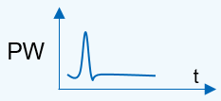  Or 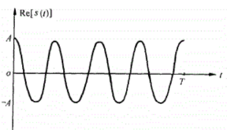 | 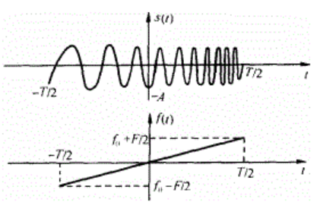
Frequency Domain  Characteristic | 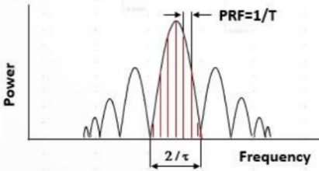 | 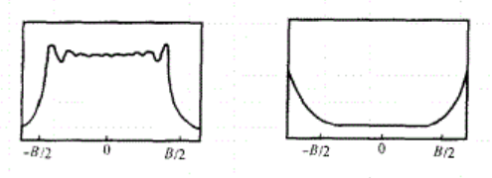
Time-Bandwidth Product (TBP) | $$τ×B=1$$ | $$τ×B>1$$
Operating State of the transmitter PA | Saturation State for larger output power | Saturation State or linear State due to large TBP
Duplex Mode | The operation of transmission and receiving is in the Time Division Duplex (TDD). | The operation of transmission and receiving is in the Full Duplex at the same time and frequency (bandwidth).
Self-interference | As TDD is used for transmission and receiving, there is no self-interference issue. | There is a strong receiving self-interference coupled from transmitter. Generally, the methods of moving target detection technology should be used to eliminate the self-interference, e.g. self-heterodyne, Pulse-Doppler Method.
Range Blind Zone | cτ/2 | If Full Duplex Operation between transmission and receiving is used, there is no Range Blind Zone for CW Radar.
Pulse Compression | Not supported | Supported. For example, matched filter is used to complete the Pulse Compression for LMF signal, but the side lobe of strong Object may interfere the detection of the small Object.

In mono-static sensing, both pulsed and continuous wave (CW) waveforms are essential to balance coverage and interference. Due to inherent self-interference (SI) limitations in co-located transceiver architectures, CW transmission is power-constrained (e.g., limited to 35 dBm). Based on our deployment experience and survey from SBFD-SBFD co-location analysis, about 65dB isolation between Tx and Rx is achievable. So the received power at Rx before antenna array is 35-65=-30dBm. Although such value is larger than what is defined in NR RAN4 spec. but to be honest, such value is feasible for RF front end. For example, assuming total 25dB amplification gain before transceiver, the input signal before transceiver is -5dBm, still in the workable range for current transceiver. So contiguous wave with 35dBm will not cause blocking at Rx side.
To extend larger detection and tracking range, pulsed waveforms are necessary as they allow for significantly higher output power (e.g., 59 dBm). By utilizing Time Division Multiplexing (TDM) between Tx and Rx, pulsed sensing effectively bypasses severe self-interference.
Based on above analysis, we have following observation.
Observation 2: self-interference is acceptable without blocking Rx RFFD by limiting output power, e.g. 35dBm contiguous wave for mono-static when assuming 65dB isolation between Tx and Rx for FR1.
To maximize spectral efficiency, SBFD can be employed during downlink (DL) sensing slots. In scenarios where sensing waveforms do not occupy the entire system bandwidth, the remaining frequency resources can be dynamically allocated for simultaneous communications. However, this co-existence necessitates stringent self-interference cancellation and high transceiver isolation to prevent desensitization. For typical SBFD deployments in FR1, an isolation requirement of 80 dB is assumed as the baseline to ensure robust sensing performance while maintaining reliable UL throughput. So besides 65dB, 80 dB Tx/Rx isolation is also suggested to be taken into consideration for certain scenarios.
Observation 3: to maximize spectral efficiency in certain special scenario, e.g. SBFD-based ISAC scenarios, an isolation level of 80 dB for FR1 can be considered as a prerequisite to enable the simultaneous operation of sensing signal transmission and uplink communication while mitigating self-interference.
Another issue is whether and how to cancellate such self-interference in digital domain. Different from SBFD self-interference cancellation, Rx may don’t need extra cancellation since the self-interference is distinct from detection signal in both frequency domain and time domain. In frequency domain, there is no Doppler shift for such self-interference while for most other use cases, the objective is moving/flying with certain velocity. Besides, the delay from Tx to Rx is much shorter for the self-interference compared with other detection signal from objectives. So usually, using the detection in frequency domain and time domain, the interference signal could be distanced from detection signal without extra needed self-interference cancellation algorithm.
Observation 4: self-interference could be distinguished in frequency domain due to doppler shift and in time domain due to shorter delay from self-interference Tx.

2.2 TRP-TRP bi-static sensing mode

bi-static sensing can circumvent complex self-interference cancellation algorithms because the spatial separation between the transmitter and receiver provides natural isolation. This isolation allows CW to be transmitted at higher power levels without compromising the receiver's dynamic range. For example, we could assume the same output power as pulse wave as in mono-static sensing mode, e.g. 58dBm. Compared with 35dBm in mono-static mode, Tx transmit with higher 23dBm, long isolation distance between Tx and Rx will contribute to this extra 23dB and avoiding blocking at Rx part.
Observation 5: self-interference is acceptable without blocking Rx RFFD without limiting output power, e.g. 58dBm with contiguous wave for bi-static due to longer isolation distance.
By leveraging high-resolution beamforming, the receiver can distinguish between the Direct-Path Signal (the self-interference or reference signal from the Tx) and the Sensing Echoes (signals reflected from the target). Since these signals arrive from distinct spatial directions (Angles of Arrival, AoA), the receiver can apply spatial filtering or "null-steering" to suppress the direct-path interference while maintaining high gain toward the target's reflection. Consequently, bi-static sensing can achieve high sensitivity without the need for complex time-domain cancellation, as the angular discrimination provides sufficient isolation.
Observation 6: For bi-static sensing, By utilizing spatial filtering (beamforming), the receiver can effectively distinguish the sensing signal from the direct-path interference based on their different Angles of Arrival (AoA), eliminating the need for additional self-interference cancellation complexity.

- Conclusion
In this contribution, we provide our view on 6G sensing use cases and related KPIs.
Observation 1: higher frequency will yield reduced clutter and avoid the overlap between clutter and target echoes without degradation in sensing accuracy.
Proposal 1: band s79, around 7GHz and band s258 are suggested as example bands for sensing feasibility study.
Observation 2: self-interference is acceptable without blocking Rx RFFD by limiting output power, e.g. 35dBm contiguous wave for mono-static when assuming 65dB isolation between Tx and Rx for FR1.
Observation 3: to maximize spectral efficiency in certain special scenario, e.g. SBFD-based ISAC scenarios, an isolation level of 80 dB for FR1 can be considered as a prerequisite to enable the simultaneous operation of sensing signal transmission and uplink communication while mitigating self-interference.
Observation 4: self-interference could be distinguished in frequency domain due to doppler shift and in time domain due to shorter delay from self-interference Tx.
Observation 5: self-interference is acceptable without blocking Rx RFFD without limiting output power, e.g. 58dBm contiguous wave for bi-static due to longer isolation distance.
Observation 6: For bi-static sensing, by utilizing spatial filtering (beamforming), the receiver can effectively distinguish the sensing signal from the direct-path interference based on their different Angles of Arrival (AoA), eliminating the need for additional self-interference cancellation complexity.

- Reference
- RP-251395, Revised SID: Study on 6G Scenarios and requirements, 3GPP TSG RAN Meeting #108Prague, Czech Republic, June 9-13, 2025.
- RP-251881, New SID: Study on 6G Radio, 3GPP TSG RAN Meeting #108Prague, Czech Republic, June 9-13, 2025.
- RP-252088
- Minimum requirements related to technical performance for IMT-2030 radio interface(s), 2 July 2025
- R4-2514592, WF on 6G sensing, ZTE

